**Draft Website Text**

**BANNER TEXT**

Charting a Course for Gender Data

Major Data Gaps Remain for Gender Equality

READ THE FULL REPORT

**HOMEPAGE PAGE TEXT**

**Gender data is our compass, guiding countries to develop and implement policies to reach our destination: an inclusive and equitable society. (side text)**

Achieving gender equality demands unleashing the power of gender data. Gender data are the basis for informed decisions, policies, and actions. Gender impacts every facet of society – from economic growth to reproductive justice. With accurate and open gender data, we can better understand people's lived experiences and accelerate progress towards a more equitable world.

But our understanding of gender data is inadequate. Nearly half the data needed to measure and monitor gender equality remain unavailable at the country-level. Beyond such quantitative gaps, we also lack information about the foundations of the gender data system—the people, politics, and power behind the data.

The Gender Data Compass (GDC) encourages us to broaden our perspective beyond the technicalities of data collection, production, and use. By providing a comprehensive view of national gender data systems, the GDC serves as a practical guide, offering direction to national statistical offices and their partners on their path to gender equality.

(Country map section can appear as is.)

**The Gender Data Compass directs us towards gender equality by providing insights to navigate the complex terrain of gender data.**

The Gender Data Compass provides information about national gender data systems and their enabling environment. It documents the current availability and openness of 53 important gender indicators in over 180 countries. It sheds light on critical questions that countries need to address to chart a course towards improvement: What official statistics are available to understand and address issues of gender equality? Are these data accessible and open to all?

The GDC also documents the environment in which the gender data system operates. Does a country have policies and laws to encourage the production and dissemination of official gender data? Is the regulatory framework, funding landscape, and national capacity strong enough to support transformative change? These issues are crucial to understanding the deeper context in which improvements can occur.

While gender data isn't the sole determinant for global gender equality, it plays a pivotal role in enabling well-informed decisions based on high-quality data. In a world filled with complex challenges, grasping the nature of such issues and their different dimensions is the essential first step toward meaningful progress. Gender data serves as the key to uncovering our shared reality, offering the insights needed to guide action effectively towards gender equality. The GDC is a starting point.

**Building gender data systems**

No country has all the gender data needed to measure their progress towards the SDGs.

**Ensuring political support**

Countries with strong mandates and legal frameworks produce more gender data.

**Investing in gender equality**

No specific allocations for gender data exist for most countries and international financing is insufficient.

**Building country capacity**

Most countries conduct fewer surveys than needed to produce gender data.

**Read the report.**

**RANKING PAGE**

The GDC rankings are more than just numbers; they serve as a powerful call to action. They can encourage the sharing of good practices, the recognition of areas of improvement, the celebration of successes, and the commitment to further progress.

Explore the rankings below by selecting global or regional rankings from the drop-down menu. You can also sort the table by clicking on the column headers.

**COUNTRY PROFILE PAGE**

While global strides toward gender equality are vital, it is at the national level that lives are transformed. Delve into the country profiles below to see how a country is progressing on its path toward data for gender equality.

Discover where gender data gaps persist, assess the openness and accessibility of existing gender data, and gauge the robustness of the gender data ecosystem through measures of governance, capacity, and financing.

**SUMMARY - SUBPAGE UNDER COUNTRY PROFILES**

The GDC provides a holistic evaluation of a country's gender data system, encompassing five vital dimensions—availability, openness, institutional foundation, capacity, and financing [COUNTRY NAME] has an overall score of [#] and ranks [#] globally and [#] in the region of [REGION NAME].

To learn more about the five dimensions and performance in each, click on the corresponding tab above.

**GENDER DATA AVAILABILITY– SUBPAGE UNDER COUNTRY PROFILES**

Comprehensive gender data coverage are essential for informed policies, tracking progress, and supporting policies for gender equity. In their absence, the gender dimensions of education, economic empowerment, health, and environmental concerns remain veiled in uncertainty. With comprehensive coverage the path to transformative change is illuminated, improving lives, and forging a more equal future.

**What gender data are available?**

The GDC looks for data across 10 categories, shown in the graph below. To understand more about why a particular score is low, scroll down to the section, “Where are the coverage gaps?”.

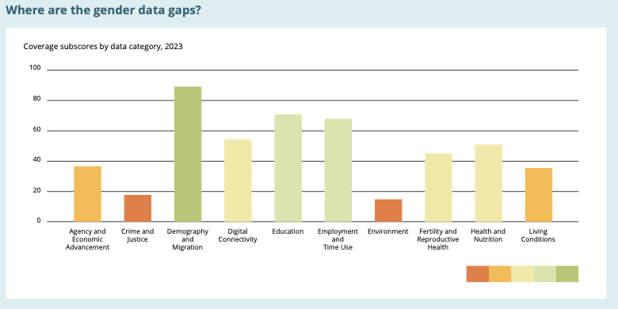

**Where are the availability gaps?** *Header text*

Select a data category from the drop-down menu to see coverage gaps in those indicators.

*(text to the right above drop-down menu)*

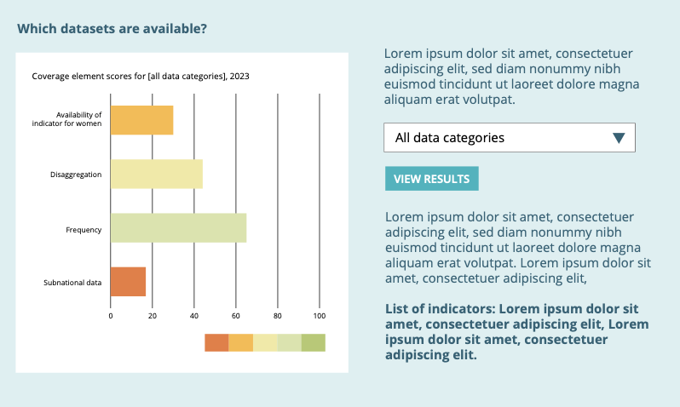

Gender data need to be comprehensive, timely, and disaggregated to maximize their impact. Here’s how to read the chart.

* Sex Disaggregation Does the country publish all indicators and are they sex-disaggregated or women-specific?
* Non-geographic Disaggregation: In addition to sex, are data disaggregated by other relevant characteristics that inform better policymaking?
* Time-series: Are there data available for up to 10 years?
* Geographic Disaggregation: Are the data disaggregated by geographic location?

**Indicators in this category**

* Indicator 1
* Indicator 2
* Indicator 3

*(text below “view results” button)*

**OPENNESS – SUBPAGE UNDER COUNTRY PROFILES**

Open data are essential for gender equality. Open data reveal disparities, support evidence-based policymaking, build trust, and drive change. They empower individuals, organizations, and nations to challenge gender inequities, fostering a world where everyone has equal opportunities and rights.

**What gender data are open?**

GDC looks for open gender data across 10 categories, shown in the graph below. To understand more about why a particular score is low, scroll down to the section, “Where are the openness gaps?”.

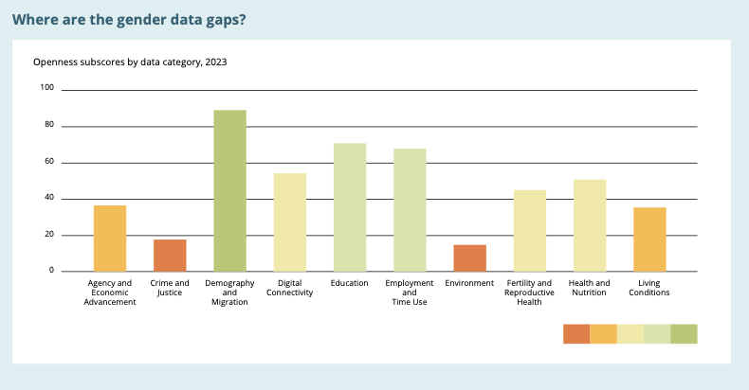

**Where are the openness gaps?** *Header text*

Select a data category from the drop-down menu to see openness gaps in those indicators.

*(text to the right above drop down menu)*

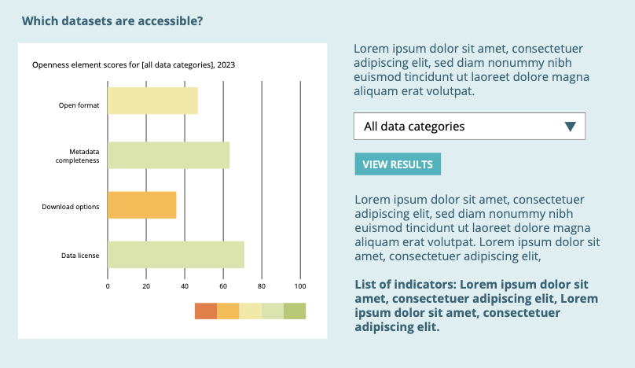

Gender data need to be accessible, easy to reuse, and licensed for reuse to be considered truly open and realize the full benefits of open data. Here’s how to read the chart:

* Open formats: Are data published in easy to reuse formats that are both machine-readable and non-proprietary?
* Metadata: Are the data accompanied by metadata that enable users to better understand the data and its quality?
* Download options: Are the data published on a platform that allows customization of the type of data downloaded?
* Data license: Are the data published under an open license that allows the free use and reuse of data, including commercial use?

**Indicators in this category**

* Indicator 1
* Indicator 2
* Indicator 3

*(text below “view results” button)*

**INSTITUTIONAL FOUNDATION- – SUBPAGE UNDER COUNTRY PROFILES**

Effective national governance of gender data requires robust legal, policy, and coordination frameworks that empower national statistical offices (NSOs) to produce and disseminate gender data effectively. These frameworks ensure that gender data collection aligns with broader government goals of promoting gender equality.

**CAPACITY – SUBPAGE UNDER COUNTRY PROFILES**

National capacity for gender data encompasses the statistical and technical strengths necessary to collect, analyze, and use gender data effectively. Capable statistical systems tailor their data collection to address unique country-specific needs and drive the development of gender data systems within their borders.

**FINANCING – SUBPAGE UNDER COUNTRY PROFILES**

Securing adequate financing—both domestically and externally—for gender data is pivotal for the sustainability of gender data systems. Such investments are vital for advancing gender equality, as they enable the collection, analysis, dissemination, and use of critical gender data, underpinning evidence-based policymaking, and the pursuit of equitable development.

**Country Support**

ODW has a proven track record of collaborating closely with countries, offering tailored workshops and consultations to help navigate their gender data landscape. Our expert guidance supports countries in understanding their GDC scores and, more importantly, identifying areas for improvement.

Your feedback is crucial. We encourage countries to actively engage with us, sharing insights, feedback, and suggestions. To initiate a conversation on how we can collaborate and support your efforts, please reach out to us at GDC-input@opendatawatch.com.

**ABOUT US PAGE**

[Open Data Watch](https://opendatawatch.com) is an international, non-profit organization. Through research, advice, and advocacy, we work to improve statistical systems, increasing the value and use of data worldwide.

Since our start, Open Data Watch has consistently advocated for open data. Through [the Open Data Inventory](https://opendatawatch.com/publications/executive-summary-open-data-inventory-2022-2023/), we have built strong and trusted relationships with national statistical offices and other stakeholders to make data for policy available and open.   
We are building on this experience to apply the principles of openness to gender data through our latest initiative—the Gender Data Compass.

This work is made possible through a grant from the Bill and Melinda Gates Foundation.

**Data Download**

This page provides the data that are used to populate the graphics and interactives throughout the website. Download data for individual countries or for all countries assessed.

Score Type Options: Raw scores have values between 0 and 1 as recorded in the original assessment; subscores are simple totals of these raw scores. Standard scores are scaled from 0 to 100; subscores are weighted averages of these standard scores.

For more information on the calculation of the scores, see the Gender Data Compass Methodology Guide.